Importing Simulink models into a C++/COM components and then adding handle_tick() to the class.

Target

Continuous:
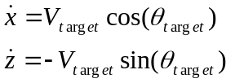

Discrete:
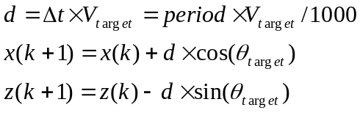

Initialization:
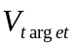=1 Mach = 328.0 ft/sec;
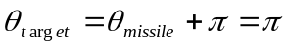
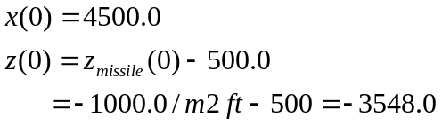

Separation Data

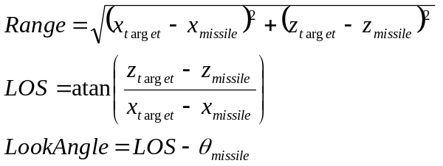

Closing Velocity

Continuous:

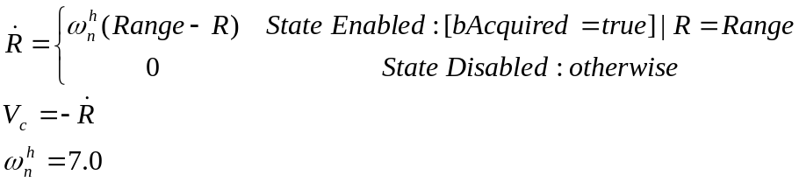

Discrete:

Run designer to compute discrete model

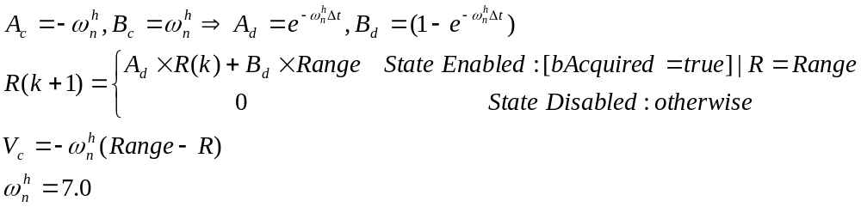

Initialization:

State=Disabled
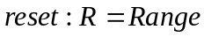

LOS Filter

Continuous:

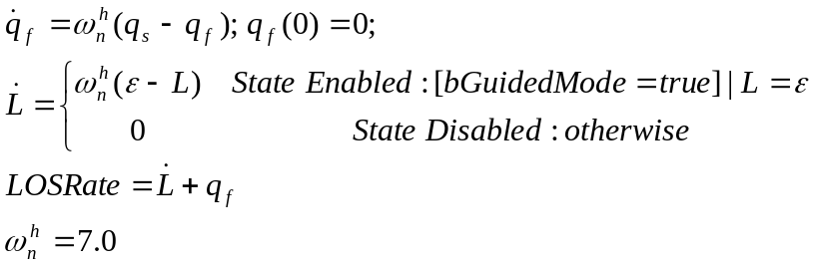

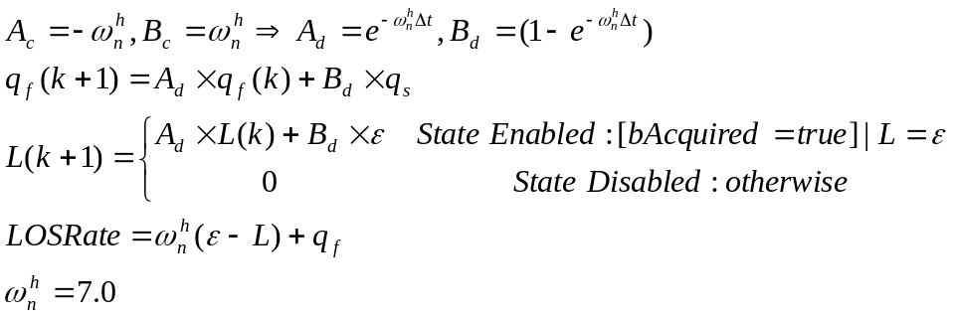

Initialization:

State=Disabled
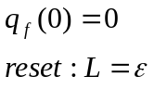

Classical Gain Scheduled Controller

Continuous:

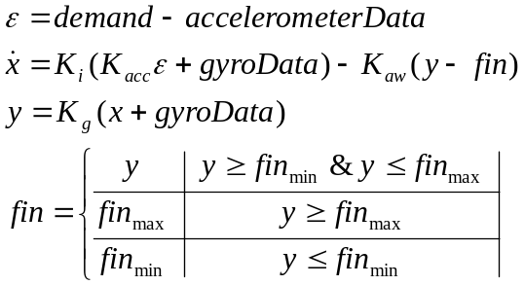
Gain Schedules:

Mach Schedule (Column Index):
2 2.25 2.5 2.75 3 3.25 3.5 3.75 4

Alpha Schedule (Row Index):
0 0.069813 0.13963 0.20944 0.27925 0.34907

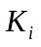:
0.025875 0.024929 0.023697 0.022902 0.021767 0.020666
0.02124 0.020401 0.019506 0.018812 0.01764 0.016757
0.017772 0.017161 0.016368 0.015623 0.014657 0.013932
0.015129 0.014569 0.01397 0.013243 0.01243 0.011823
0.012987 0.012563 0.012018 0.011416 0.01072 0.010204
0.011307 0.010911 0.010484 0.0099827 0.0093773 0.0089312
0.0099923 0.0095967 0.0092032 0.0088348 0.0083011 0.0079114
0.008851 0.0085331 0.0081704 0.0078695 0.0074244 0.0070803
0.0079166 0.0076584 0.0073244 0.0070834 0.0067001 0.0063934

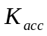:
0.94124 0.93886 0.93521 0.93213 0.92734 0.92171
0.93637 0.93359 0.93004 0.92655 0.9203 0.91417
0.93156 0.92895 0.92496 0.92041 0.91367 0.90709
0.92691 0.92392 0.92007 0.91464 0.90746 0.90047
0.92195 0.91912 0.91483 0.90923 0.90164 0.89429
0.91726 0.91404 0.90988 0.90418 0.8962 0.88852
0.91305 0.90925 0.90467 0.89947 0.89112 0.88314
0.90839 0.90474 0.89978 0.89466 0.88638 0.87812
0.90398 0.90049 0.89519 0.89028 0.88197 0.87347

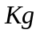:
0.85026 0.843 0.83498 0.82901 0.82515 0.82338
0.66882 0.66155 0.65353 0.64755 0.64369 0.64191
0.53969 0.53242 0.52439 0.5184 0.51453 0.51275
0.44476 0.43748 0.42943 0.42344 0.41956 0.41777
0.37312 0.36583 0.35777 0.35176 0.34788 0.34608
0.31788 0.31058 0.30251 0.2965 0.2926 0.29079
0.27393 0.26723 0.25915 0.25312 0.24922 0.2474
0.23943 0.23272 0.22462 0.21858 0.21467 0.21285
0.21164 0.2049 0.19679 0.19074 0.18682 0.18499

Discrete:

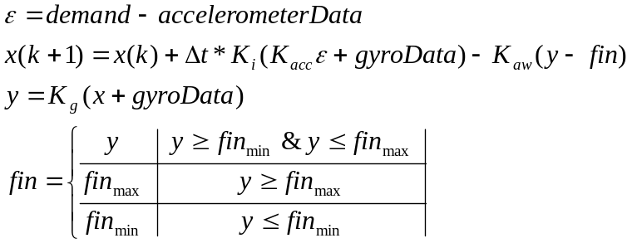

Initialization:

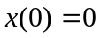

Fin Actuator

Continuous:

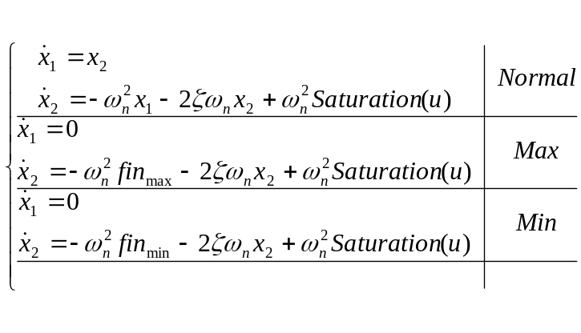
Initialization:

